Featherstone All Saints C of E Academy
North Close,
Featherstone,
Pontefract
WF7 6BQ
‘To grow and to flourish’

Tel. 01977 780225
E-mail: headteacher@allsaints.wakefield.sch.uk
Head teacher: Mr Jones

14th March 2023
Dear Parents / Carers,
As far as we are aware, we are not affected by the planned industrial action on Wednesday 15th March and Thursday 16th March. School will be fully open as usual to all classes. If this situation changes, we will inform you as soon as possible, however please be aware this can be as late as the morning of the planned industrial action.
Kind regards,
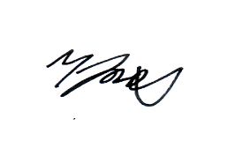

Mr. M. Jones (Head teacher)

