**Featherstone All Saints C of E Academy**

North Close,

Featherstone,

Pontefract

WF7 6BQ

**‘To grow and to flourish’**

Tel. 01977 780225

E-mail: headteacher@allsaints.wakefield.sch.uk

Head teacher: Mr Jones

21st March 2023

Dear Parents / Carers,

Hand to Mouth

On Monday 6th March, *Hand to Mouth* came into school with a focus on Lent and Holy Week. In class, the children explored these different elements. They delivered whole school worship based on the events that took place during Holy week. In Years 3 and 4 they went on a journey into Lent and reflected on what had happened to Jesus during this time. They also sampled *'the bread'* and looked at how Easter eggs symbolise Jesus' empty tomb.

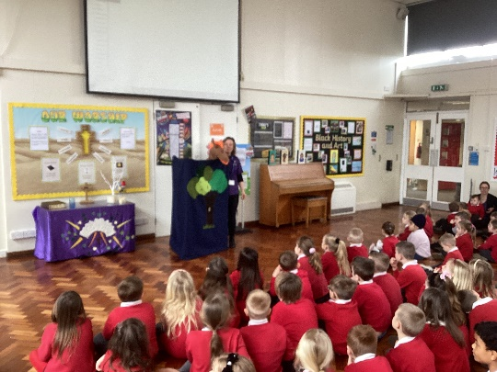



Comic Relief – Red Nose Day 2023

We raised a fabulous total of **£131.60** for the Comic Relief. Thanks for all your donations – it goes to a very worthwhile cause and will make a difference.

Staffing

Unfortunately, Mrs. J. Applegarth (temporary part-time Year 5 teacher) will be leaving our school at the end of the spring term. She only joined the school on a temporary basis after Christmas but has recently gained a permanent role in another Wakefield trust, supporting a school in difficulties. We have reluctantly agreed to allow her to start this role in the summer term and Mrs. D. Kerr will now take the Year 5 class on a full-time basis. After Easter, Miss. A. Everitt will undertake Mrs. D. Kerr’s current part-time Year 1 duties, working alongside Mrs. K. Morgan-Meek.

I would like to thank Mrs. J. Applegarth for her hard work this spring term and wish her all the best in her future role.

Attendance

Spring term (5th September to 19th March)

|  |  |  |  |
| --- | --- | --- | --- |
| Reception | 95.2% | Our school attendance target is **97%** |  |
| Year 1 | 94.2% |
| Year 2 | 94.9% |
| Year 3 | 96.1% |
| Year 4 | 94.1% |
| Year 5 | 94.3% |
| Year 6 | 96.4% |
| Overall | 95.0% |

Key Diary Dates

* **Wednesday 22nd March** – Class photos.
* **Thursday 30th March** - **Easter Service** at All Saints Church at 9.30 am (Year 1 to lead). Parents / carers welcome.
* **Thursday 30th March** – **School breaks-up** for Easter; **early 2.00pm finish**. We return on Monday 17th April.
* **Friday 31st March** - School closed (INSET day)

**School INSET days:**

* Friday 31st March
* Monday 24th July
* Tuesday 25th July

**Bank Holidays:**

* Monday 1st May
* Monday 8th May – An additional date for the Coronation of His Majesty King Charles III

**Key Assessment Points**

* Key Stage 2 (Year 6) SATs week – 9th to 12th May 2023
* Key Stage 1 (Year 2) testing period – 15th to 26th May 2023
* Phonics Screening Test (Year 1) – Week beginning 12th June 2023 (one week window to administer)
* Multiplication tables check (Year 4) - Week beginning 5th June 2023 (three-week window to administer)

Kind regards,

*Mr. Jones*

Mr. M. Jones (Head teacher)