Feedback on remote learning January 2021 (22.01.21)
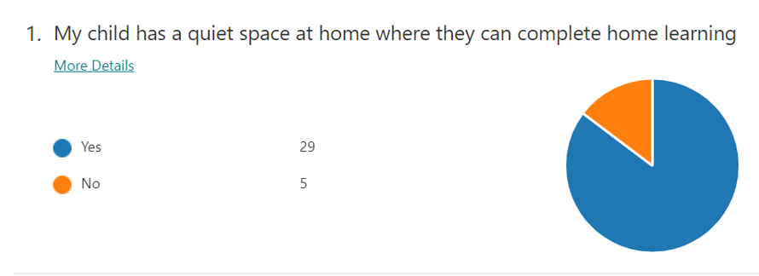
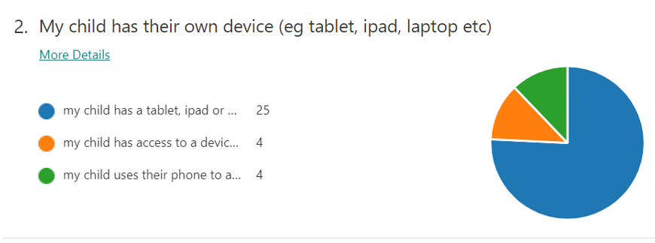
School has 16 devices that we can loan out. Some families have already been contacted and devices 10 loaned out. Message on Dojo to let parents know that they can contact school if a child is sharing a device with a sibling.

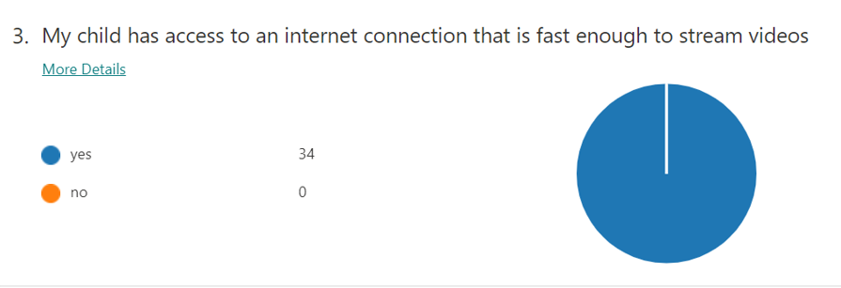
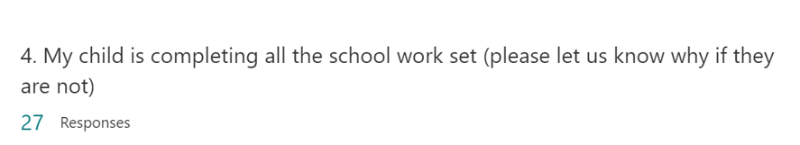
- The majority of parents said that the amount of work set was just right
- 2 parents said that sometimes they run out of time in an afternoon session

Parents encouraged to contact the class teacher if they are having trouble completing the work

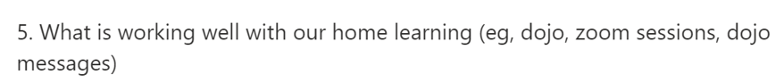
- Zoom lessons so there is regular contact between children and class teacher
- Good communication between home and school
- Dojo is easy to use and parents like the feedback and being able to message the class teacher
- Having a plan of the work and a daily schedule.
- Very organised

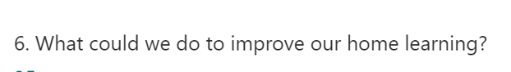
- Daily timetable and schedule
- Work for Dojo to be uploaded the day before so that parents can print it off
- More Zoom lessons – perhaps an afternoon session to go through the topic work

As a result of the feedback, staff will ensure that there is a daily schedule and work is uploaded the day before. Regular zoom lessons to take place to keep up the contact between home and school.

