Featherstone All Saints CofE Academy


SEND Information Report

Approved by: | Governors | Date: September 2025
Last reviewed on: | November 2024
Next review due by: | September 2026

This report is contributing to Wakefield Local Authority’s Local Offer. Please see the link below for further information:

https://wakefield.mylocaloffer.org/Home

Here at Featherstone All Saints CofE Academy, we pride ourselves on an inclusive ethos where the needs of the individual pupil are paramount. We adhere to the admissions policy of Wakefield Local Authority.

We hope you find the following information useful.

How does the school know if children/young people need extra help and what should I do if I think my child/young person may have special educational needs?

All children’s progress, academically, socially and emotionally, is constantly monitored by teachers and the Senior Management Team (SMT) within the school. On entry into school, pupils are assessed against national standards. Each child’s progress is then monitored carefully. If the pupil’s progress is causing concern then parents are informed and invited into school to discuss the next steps. A Supporting Me to Learn Plan (SMTLP) may be put into place at this time alongside a One Page Profile (OPP) and options regarding possible external agency involvement may be discussed.
At Featherstone All Saints we work with parents and outside agencies to help to identify children with a range of needs including: Sensory Impairment; Social Communication and Interaction needs; Speech and Language communication needs; Physical needs and Social and Emotional Mental Health needs.

If you have concerns about your child’s progress then we would encourage parents to initially speak with the class teacher. Further meetings may then be arranged with the Special Educational Needs Co-ordinator (SENCo) - at Featherstone All Saints CofE Academy the SENCo is Dianne Tunningley. In the event of staff absence, a temporary SENDCo will be available.

If you would like to speak to the school SENDCo you can arrange this through the school office, alternatively you can ring school on 01977 780225 to arrange a telephone consultation or a meeting in school.

How will school staff support my child/young person?

If a child is identified has having Special Educational Needs their class teacher, alongside the child and the SENDCo will create a One Page Profile. This is a one page document that details information about the child that will help all staff in the relevant classroom to support the child. This may include information such as the child’s likes and dislikes and any resources that the child uses to help them focus and/or learn.
Class teachers plan for every child within their class and children with Special Educational Needs are given an additional support plan to meet their needs. This Supporting Me to learn Plan (SMTLP) is developed by the class teacher alongside the child. The plan has two or three key targets which are small, measurable and relevant. The targets may include strategies to support both parents and staff within school working with the child. The children will then work towards these targets until they are met or the next SMTLP review. If the child/children meet their set targets before their next scheduled SMTLP review an earlier review, to set new targets, may be arranged. The plan also utilises advice from any outside agencies who may be involved with the child. The child is able to identify areas he or she wants to work on and this is shared with parents/carers. SMTLP are reviewed every term with the child and shared with parents. All correspondence about any child is passed to the school’s SENCO who also monitors all SMTLPs termly.

If the child has been on a Supporting Me to Learn Plan and has still made little progress, the school may wish to ask Outside Agencies to become involved. In order for these agencies to become involved, a My Support Plan (MSP) will need to be written (this describes the key areas of need for the child) and a referral made. This will work alongside the child’s Supporting Me to Learn Plan and reviewed termly with the school and agencies involved.
If a My Support Plan is in place and the school and Outside Agencies feel more support is needed, a request for a formal Education Health Care Plan will be made to access additional funding to support the child.
The school SENDCo will oversee the progress of all children who have been identified as having Special Educational Needs and will meet regularly with your child’s/children’s class teacher to ensure that support needed is in place.
Staff in school are well-trained to meet the needs for our young people. Currently in school we have a trained Dyslexia expert in addition to multiple REACT and First Aid trained members of staff. All staff are trained in Safeguarding and teaching staff all have regularly training on Asthma and Epi-Pens. If a training need is identified it is quickly addressed so that the highest level of care is always in place for our young people.

How will the curriculum be matched to my child’s/young person’s needs?
Through ‘Quality First Teaching’, school provides a curriculum to meet the needs of all children. All lessons offer the challenge and support necessary for each child to learn and where necessary differentiation occurs through planned activities, appropriately framed questioning or the support given. Lessons are planned to engage all types of learners including: special; auditory; kinaesthetic and linguistic learners. However, on occasions, a child may require more specific activities working in a small group or individualised support. At Featherstone All Saints CofE Academy we have a number of such intervention groups; examples include Rainbow Words, Phonics Catch Up, Lego Therapy. The impact of these are monitored regularly by the class teacher and the SENDCo throughout the term. The information gathered from the monitoring process is then used to inform a decision regarding any further interventions that may or may not be needed. If you would like to find out if your child is currently accessing any interventions in school please speak to your child’s / children’s class teacher.

How will I know how my child/young person is doing and how will you help me to support
my child’s learning?

There is an opportunity at the start or the end of the school day to briefly discuss your child and also arrange an appointment to meet your child’s class teacher or the SENCO. Parent Consultation meetings are held during the Autumn and Spring term, to discuss your child’s progress. In addition, the parents of those children who are on the SEN register are given opportunities to discuss and review their SMTLP and are invited to a ‘drop-in’ session on a termly basis.

Strategies are discussed at these meeting for parents/carers to support their child’s learning and teachers are available to discuss any concerns or issues throughout the school week. All children are tracked using school’s data tracking.

What support will there be for my child’s overall well-being?
Featherstone All Saints CofE Academy ensures that all children are supported socially and pastorally by staff who know their children.

School offers a wide range of activities both within school and the community to support their social and emotional development such as school visits, educational trips, links with the community and a range of cultural visits.
School has a medicine policy which supports parents/carers with the management of their child’s medication within school and staff regularly undergo training in key areas such as asthma, epilepsy and the use of Epi pens. If a child comes into school with a specific need, the school nurse will provide the relevant staff with training. The school also trains members of staff within school as first aiders ensuring we always have trained staff on any visit outside of school.

School has a behaviour policy which is known, used and adhered to by all staff across the school. Exclusions are rare in school and this is due to the high expectations school has of children’s learning and behaviour and the support from parents/carers. Children who need specific support with their behaviour will be identified and support will be provided. This support may range from additional support in the classroom, to interventions and support from the Behavioural Support Team or Learning mentor. Good behaviour is celebrated across school through class rewards and certificates.

Incentives to promote excellent school attendance include whole class certificates for 100% weekly attendance and individual certificates on a termly basis. School will text/ ring home to query a child’s non- attendance at school. School uses an Education Welfare Officer (EWO) who will support school and parents with ensuring children attend school regularly and on time.

What specialist services and expertise are available at or accessed by the school?
School employs trained staff to educate and care for children throughout their primary years. Staff training is updated regularly in key areas of the curriculum and also in identifying and supporting children with specific difficulties around learning, child development and social and key emotional problems children may experience. School has direct access to a wide range of services all of which can support both parents/carers and children. These agencies include, WISENDSS speech and language, child psychology, the schools counselling service, CAMHS, Behaviour Support, Early Years, Social Services, Paediatricians and the school nurse.

What are the options for staff training?
All staff receive regular training from the health service around key medical issues which could arise for children e.g. delivering physiotherapy to individual pupils. Certain staff are trained in First Aid and are strategically placed around school. The SENCO attends Local Authority training which is then shared with all staff. Many staff are REACT trained, which provides staff with ‘a framework to equip individuals with attitudes, skills and knowledge to facilitate environments that are free from fear and safe from harm.’ In school, we also have a specialist trained in dyslexia who delivers interventions to children when a need has been identified. The SENCO provides in-house training on developing SMTLPs and around specific requests from staff, or as necessary to support a particular child or group of children.
Where necessary for specific situations, specialist training is bought into the school. For example Communication Interaction Training to support pupils with limited language from the WISENDSS team who provide school with training around a range of social and emotional needs.

How will my child/young person be included in activities outside the classroom including school trips?
Featherstone All Saints CofE Academy is fully-inclusive and all children attend all events and trips and are encouraged to take part in all activities both within and outside of school. Where necessary, extra support will be provided to ensure full participation by all children and parents are fully-informed as to the trips and activities open to every child. Some of the trips and educational visits may be subsidised by the school to ensure all children can access these extra-curricular activities.

How accessible is the school environment?
Featherstone All Saints CofE Academy is mainly all on one level and but there steps to two outdoor classrooms that are separate from the main building. We have a disable toilet in the main school building but no dedicated disabled changing facilities.

The use of computers, tablets and laptops enable all children to have access to new technologies to support their learning.

How will the school prepare and support my child to join the school or to transfer to a new school or the next stage of education and life?

School encourage parents and children to visit the school and meet their new teacher prior to joining the school. A member of the School Leadership Team will show the child and parents around school and be available to answer any questions. Meetings are organised in the Summer term, prior to entry into the foundation stage. If children are joining our setting, the SENCO, Dianne Tunningley, will contact their previous school to ascertain information. The SENCO meets with SENCOs from feeder schools to discuss individual needs prior to the Year 6 pupils leaving in July.

How are the schools resources allocated and matched to children’s special educational needs?

In April every year, the school receives a notional SEN budget. This funding is intended to support both existing SEN pupils with low cost High/incidence SEN and the first £6000 of support for high cost pupils.

The school may receive additional funding (known as top up) agreed through the SEN panel (for high costs pupils) commensurate with the child’s level of need; 25% of the notional SEN will be used to support low cost/high incidence SEN and 75% of the notional SEN budget will be used to support the first £6000 of high cost pupils.
This 25% of the national SEN funding provides the mainstream support that the majority of children require. For example, it contributes to the costs of training provided by outside agencies, additional external agency support such as speech and language therapy and play therapy, smaller class sizes and for support staff to work in class/ small group work, specialist resources which may be required – e.g. specialist chairs, lap tops, ICT software as well as time for teachers to complete meaningful individual education plans with the child and share with parents. Children in this category are classed as high incidence, low needs.

How is the decision made about what type and how much support my child will receive?

The school curriculum is differentiated to meet the needs of all children and this differentiation can take the form of: targeted questions, a change to the curriculum, support within the classroom by the class teacher or support staff and on occasions, the format in which tasks are given may be different. After discussing a child’s specific needs alongside the parents/carers and the child, the decision to give children extra support is determined in the first instance by the class teacher. He/she will make that decision if it is felt a child is not making sufficient progress in any particular area. Depending on the need, the class teacher will make the decision how to support a child. If a class teacher decides that a child needs more

specialised help or more targeted support he/she will speak to the SENCO, who will determine if specialist advice is needed. The specialist support will be dependent on the need of the child but the professional involved could include: Wakefield Inclusion and Special Educational Needs / Disabilities Support Service (WISENDSS), Speech and Language support, Educational Psychologist support, Wakefield CAMHS (Child and Adolescent Mental Health Service), and Future in mind (FIM) support plus school has access to a learning mentor in school. Further to this, the school holds ‘Drop in Meetings’ at which professionals are present to discuss provision for supporting children and families in school.

Who, at the school, can I contact for further information?
School has an ‘open door’ policy which means all staff are available every morning to meet their class and at this point parents/carers could ask for a meeting to discuss their child with the class teacher. If parents/carers feel that they wanted to discuss their child and their specific needs or any concerns they may have they can either, make an appointment to see the Head Teacher, or SENCO within the school. If parents are dissatisfied with the school’s response then Wakefield’s Parent Partnership service can become involved.

If you are considering sending your child to Featherstone All Saints CofE Academy, you can ring the school on 01977 780225 to make an appointment with the Head Teacher, Mr. P. Burton, to arrange a visit to the school. During the visit you may be given a tour of the school by either a Senior Leader or the administration staff. At that point you will be given opportunities to discuss your child’s specific needs and ask any questions relating to your child’s education.

What agencies can I contact for advice and support?
There are several agencies that have been created by the government and other areas to support parents of children who have, or who have special educational needs. In Wakefield our local support services are called WESAIL and SENDIASS.

WESAIL

Wakefield Early Support, Advice, Information and Liaison (WESAIL) provides a free, confidential and impartial service - which means we do not take sides and try to ensure everyone is given opporunities to express their views and feel listened to.

WESAIL provide information, advice, support and signposting according to need by either by telephone or where needed on an individual or targeted basis or through events and workshops. We share details of events on the Local Offer, our facebook page and provide information through the Information Network.

WESAIL offers information covering a range of matters relating to Special Educational Needs and/or Disabilities (SEND) including education, health, social care, personalisation, personal budgets along with benefits and leisure.

The aim of the WESAIL service is to support children, young people, their parents, carers and families by providing information to navigate systems and processes so that they can play an active role in decision making about matters relating to their or their children's health, education, social care to support and empower them in meeting their child's needs and promoting self-advocacy.

Referrals for support can be made by telephone or directly to the service by either:

Young People

Parents or Carers

Someone working with the family where the parent/carer or young person has given consent

WESAIL is also responsible for updating the Local Offer and engaging with children, young people, families and stakeholders in its ongoing development and review. The aim of the local Offer is to help people easily find information about the services, activities and support available in the local area for children and young people with Special Educational Needs and /or Disabilities and their families.
Full information on the services that they offer can be found on their website:
https://www.wakefieldparentcarers.co.uk/sendiass-barnardos-wesail

The WESAIL contact information is:

The WESAIL telephone number is 01924 965588

The WESAIL email address is wesail@family-action.org.uk

The WESAIL website address is https://www.wakefieldparentcarers.co.uk/sendiass-barnardos-wesail

15. Complaints procedure.

If you have a complaint, regarding your child / children that has been identified has having / may have Special Educational Needs and is currently a student at Featherstone All Saints CofE Academy then you may choose to follow the complaints procedure for the Enhance Academy Trust that is detailed on our school website here:
http://www.allsaints.wakefield.sch.uk/key-information/school-policies A brief outline of the procedure is below:
PROCEDURE FOR DEALING WITH GENERAL COMPLAINTS
Each stage should be completed before progressing to the next stage.

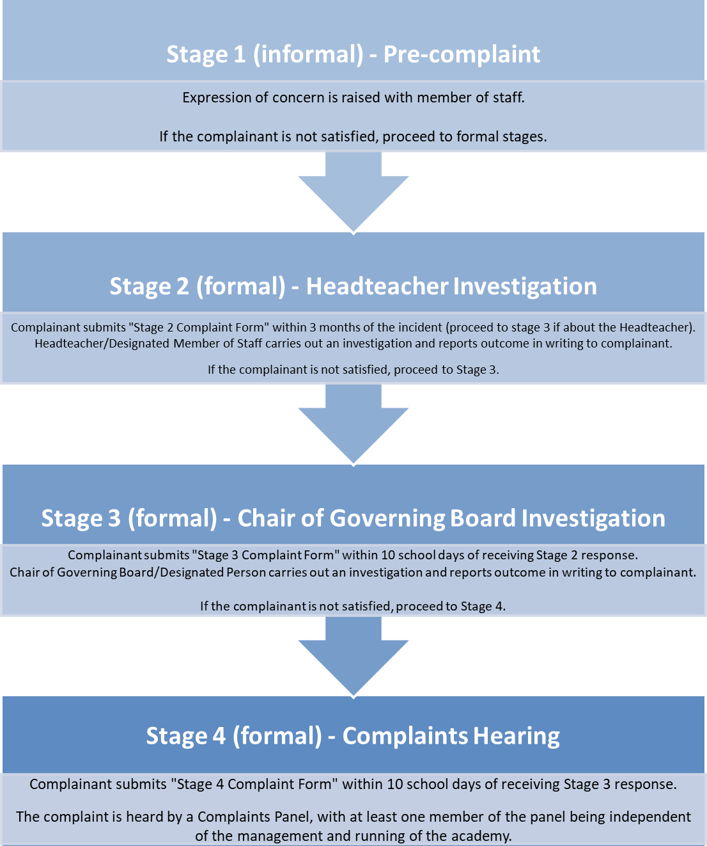

There is no further right of appeal. If the complainant is not happy with the handling of their complaint, they may contact the DFE & Secretary of State for Education.

