Headline Data
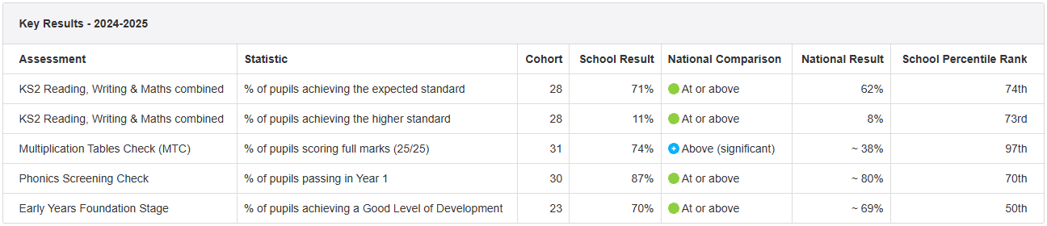

Key Stage 2 Performance
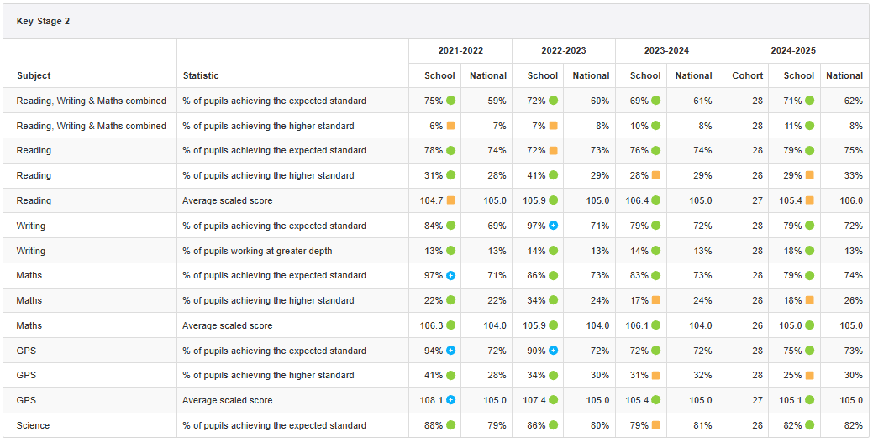

Year 4 Multiplication Tables Check
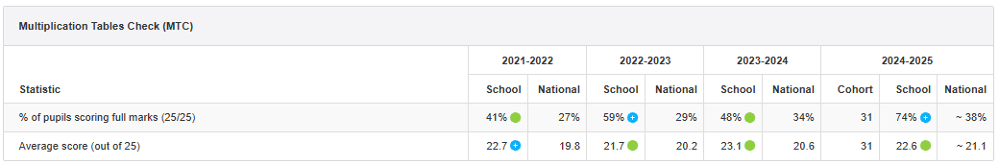

Year 1 Phonics Screening Check (Year 1 and 2)
